**Baseball Analysis Project Report**

This project is for Udacity Data Analysis course. There are 28 data sets on the “Sean Lahman” website. In this project, I focus on Wins and Salaries and compare two different roles in Baseball Game.

**Abstract**

The main question I want to answer in this project is ‘What is the best model for predicting Wins for each team?’; Base on Baseball rules, wins related to Runs, so I will focus on modeling runs base on variables we already have. First I will look at data in different ways and try to understand how wins and salary relate to each other. For this reason, I will ask 9 questions and finally I will develop a model for predicting runs.

In this project, I used these data sets from the mentioned source:

Master, Batting, Pitching, Salaries, Teams.

**Main Questions:**

For being familiar with these datasets, I will look at these questions:

1. How players’ salaries are distributed? is it normal or skewed?

2. How to measure teams’ financial efficiency base on their payroll?

3. Who is the most paid pitcher in 2015?

4. Which key characteristics of the most paid pitcher is significantly different from other pitchers?

5. Who is the most paid batter in 2015?

6. Which key characteristics of the most paid batter is significantly different from other batters?

7. What is the trend of changing salaries over the time?

8. How does number of Wins change over the time?

9. Is there any difference on average between Batters and Pitchers Salary?

10. What's the best model for describing Wins for each team? Which features are best relate to Wins?

1. **Salaries Distribution**

For better understanding the salaries, I will look at salaries stats:

count 4951

mean $3,671,903

std $4,909,905

min $400,000

25% $504,000

50% $1,300,000

75% $5,000,000

max $33,000,000

And here is the histogram of Salaries from 1985 to 2015:

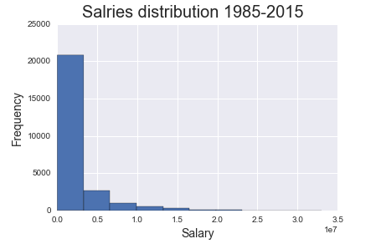

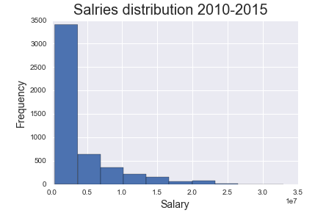Maybe the reason of skewness is that we are looking at 30 years; for making it more clear, I will look at the most recent 5 year:

It seems the salaries distribution is skewed; again, for considering it and making it more clear, I will calculate Pearson's second skewness coefficient (median skewness):

Yearly Salaries Median Skewness is: 1.39159693472

It means that Salaries are Positively Skewed. Because the median skewness is positive.

1. **Teams Payroll vs. number of their Wins**

Baseball teams goal is to get Wins and on the other hand they should pay salary to player; At a financial point of view they try to get more Wins and pay the whole payroll less. There is a dilemma like other business situations. First let’s look at the relationship between Payroll and number of Wins each team has in each year:

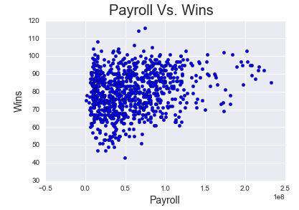

Base on this scatter plot, most teams spend an average money and get an average Wins. Efficient teams are ones which spend less money and get more Wins. For modeling this concept, I am defining a criteria base on Wins and Payroll. The criteria can be the ratio of number of Wins to total Payroll and multiply it to 10^6 to have more reasonable numbers. Because the ratio without this multiplication has a factor of 10^-6;

Then I define a function to find the most efficient team in each year base on this criterion. In the code, I run this function for 2000 to 2015 years and the result is hereunder:

2000 (MIN, 4.17688186688)

2001 (MIN, 3.52258599254)

2002 (OAK, 2.57473177732)

2003 (TBA, 3.20937340805)

2004 (MIL, 2.43384129175)

2005 (TBA, 2.25748336361)

2006 (FLO, 5.31642981290)

2007 (TBA, 2.73592140444)

2008 (FLO, 3.85117942370)

2009 (FLO, 2.36194820003)

2010 (SDN, 2.38099647348)

2011 (TBA, 2.21661594311)

2012 (OAK, 1.69759357082)

2013 (HOU, 2.85064307154)

2014 (HOU, 1.99337629534)

2015 (ARI, 1.27761425753)

Base on the above results, we can find out which teams are the most efficient in each year, refer to their total payroll and number of wins they have in that year. As an example, we can see in year 2002 the Oakland A's is the most efficient team; It was in the Billy Beane era and starting using analysis for recruitment. In 2002, the Athletics became the first team in the 100 plus years of American League baseball to win 20 consecutive games. The nice point is that they got this record with a very low payroll. And it means exactly the efficiency I mean.

It's not necessary that a team with a high efficiency ratio, has a high rank in a championship. It only means that base on the money they spent, they got relatively high wins.

1. **The most paid Pitcher in 2015**

I want to know who is the most paid pitcher first and then find out which characteristics he has for being in this level of salary.

First I need to merge Pitching data frame and salary data frame. The base for this merge should be the Pitching data frame. And then finding the most salary in the merged data frame. Base on code I wrote, here is the most Pitcher:

*Clayton Kershaw.*

1. **Key characteristics of the most paid Pitcher**

For understanding the key characteristics, I calculate the z-value for all columns and base on what we know about normal distribution, I will look at the z-values related to the most paid pitcher that are more than 3. It means that the most paid Pitcher has a better performance than 99.9% of the population. Base on the code, I think the key factors are these ones:

**SHO, CG, BK, SO, W**

1. **The most paid Batter in 2015**

The explanation is like topic 3; And the answer of this question is:

Alex Rodriguez

1. **Key characteristics of the most paid Batter**

Again, the explanation is like topic 4 and the key characteristic for him are:

**HR, RBI, BB, SO, SF, GIDP**

I should mention that in the current topic and topic 4 I don’t mean these characteristics are the cause of big salaries, I only realize there is a positive correlation between big salaries and these performance values.

1. **Yearly Salary Trend**

In this question, I am looking at the total salary paid to players over the past 30 years. This question can be considered as part of baseball economics. I mean how the whole money that paid to all players changed over the last 30 years.

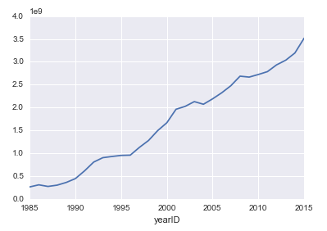

It means that the whole baseball payroll folded 13 times over the last 30 years.

1. **Number of Wins Changes Over Time**

Now I am looking at the total number of wins in the last 30 years;

It means total number of wins has an absolute growth from 2100 to more than 2400; There is an interesting year in this graph:

Year 1994. There should be a reason for dropping total number of wins in that year.

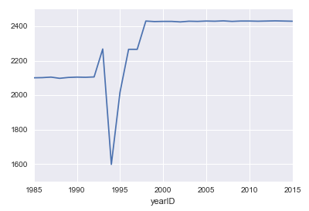

1. **Difference between Batters and Pitchers Salaries**

Another question worth to think about is the difference between Batters and Pitchers salary on average. I mean is there any difference at all and if yes, what is this difference?

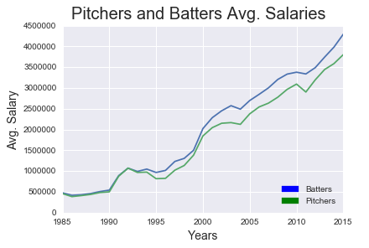

Base on this plot, it seems like the average salary for batters are more than Pitchers. For testing this arbitrary conclusion, we can calculate the ratio of these two series and look at the average ratio over the years; The average ratio of these two salaries is: 1.11;

It means that the average Batters salary is 11% more than the average Pitchers salary in this 30 years.

1. **Modeling Team Wins**

Base on baseball rules, the winning team has more runs. So, the most important criteria for modeling Wins is Runs. I am looking at correlation between Runs and other features for teams and find out the most correlated characteristics. I need these features to model runs correctly. I will use a linear regression model with those features.

Base on correlation coefficients after running the code, those numbers suggest that Runs has a strong correlation with R and H; R is Runs itself and it's obvious any variable has a 100% correlation with itself. H is Hits and again it's an obvious correlation; Because Hits are the major cause of Runs. The other correlations are not very high, so I will define some new variables and look at their correlation with Runs; These new variables are:

**BA**: Batting average

**OBP**: On Base Percentage

**SLG**: Sluggish Percentage

And do the correlation coefficient calculation between Runs and these new variables;

Based on these correlation numbers, we conclude that all three new variables have a high correlation with Runs. Now is time for modeling. For linear regression modeling I will use *statsmodels* library in python.

We know that the best model would be the model with maximum R-Squared;

The first model for Runs is using only BA as feature. Because BA was one of the most powerful predictors for Runs. After this simple model, I tried several other combinations of most correlated features with Runs. The second model uses three features: OBP, SLG and BA; The third model uses two features: OBP and SLG;

The R-Squared for the second model is less than two other models, So I think it’s the best model for predicting Runs and there after predicting Wins.

The Second Model for Runs is as follows:

R = -864.83 + 2676.15 * OBP + 1741.78 * SLG + 14.08 * BA

For visually testing this model, I plot the real Runs and Predicted Runs base on this model; The result is as follows:

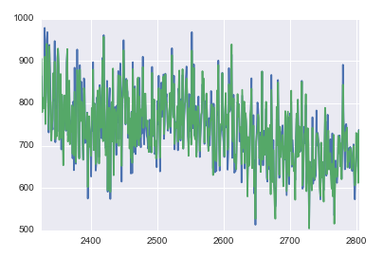

The First Model for Runs is as follows:

R = -627.94 + 5010.09 * BA

The prediction vs. values we have for Runs are as follows:

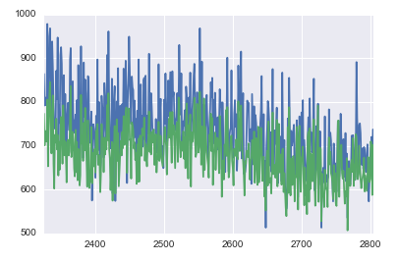

Based on these graphs, it’s clear that the first model is a better predictor for Runs.